***1st assignment***

1. **Ping another computer**

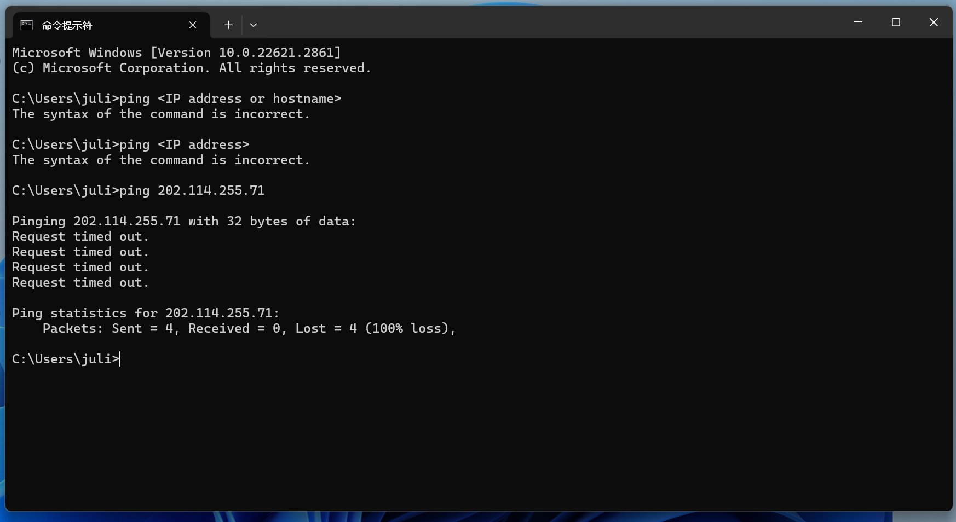

The computer did not receive any responses within the expected time frame. Each "Request timed out" message indicates that no response was received from the destination within the specified timeout period.

The "Ping statistics" section summarizes the outcome:

* "Packets: Sent = 4" indicates that your computer sent out four ping packets.
* "Received = 0" indicates that none of these packets were received back.
* "Lost = 4 (100% loss)" means that all four packets were lost, indicating a 100% loss rate.窗体顶端

1. **tracert a server**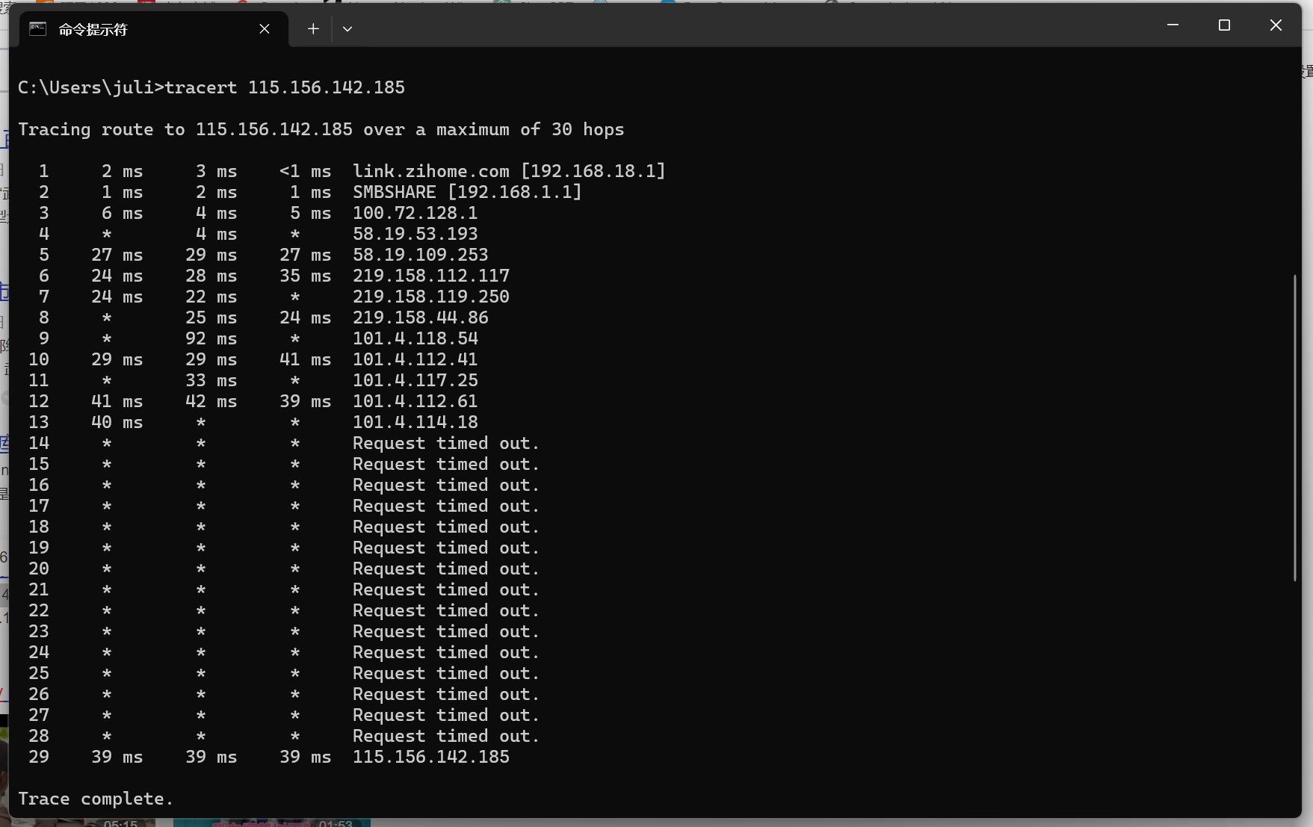
2. **register a github account, download lab resource from https://github.com/wireshark/wireshark**

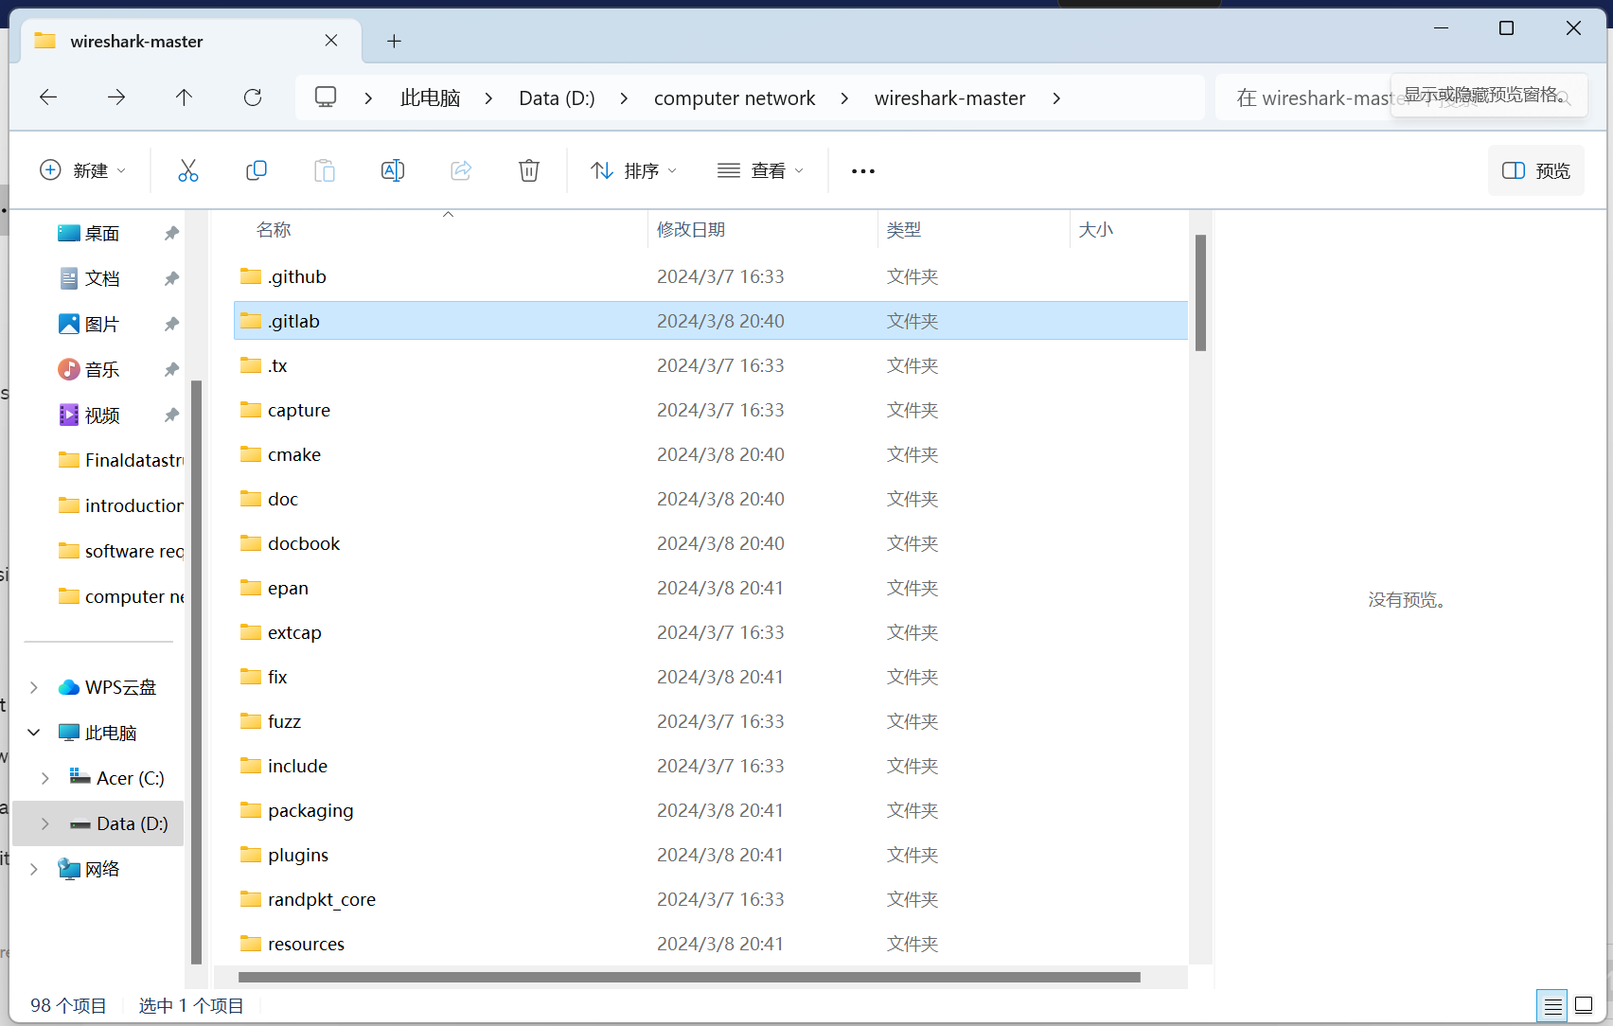

***2nd assignment***

**P8. Suppose users share a 10 Mbps link. Also suppose each user requires 200 kbps**

**when transmitting, but each user transmits only 10 percent of the time. (See**

**the discussion of packet switching versus circuit switching in Section 1.3.)**

**a. When circuit switching is used, how many users can be supported?**

**b. For the remainder of this problem, suppose packet switching is used. Find**

**the probability that a given user is transmitting.**

**c. Suppose there are 120 users. Find the probability that at any given time,**

**exactly n users are transmitting simultaneously. (Hint: Use the binomial**

**distribution.)**

**d. Find the probability that there are 51 or more users transmitting**

**simultaneously.**

a. In circuit switching, the entire bandwidth of the link is reserved for each user for the duration of their connection. Since each user requires 200 kbps and the link capacity is 10 Mbps, the number of users that can be supported simultaneously is:

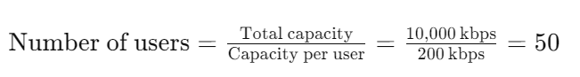

b. In packet switching, the probability that a given user is transmitting can be calculated using the offered load, which is the product of the average data rate per user and the average holding time (time the user is active).

The average data rate per user is 200 kbps and the holding time is 10% of the time. Therefore, the offered load is:

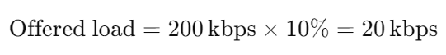

To find the probability that a given user is transmitting, we divide the offered load by the total capacity of the link:



c. To find the probability that exactly n users are transmitting simultaneously out of 120 users, we can use the binomial distribution. The binomial distribution gives the probability of having k successes in n independent Bernoulli trials with a probability p of success in each trial.



where:

n is the number of trials (total number of users = 120),

k is the number of successes (number of users transmitting simultaneously),

p is the probability of success (probability that a given user is transmitting),

 is the binomial coefficient.

d. To find the probability that there are 51 or more users transmitting simultaneously, we sum the probabilities of having 51, 52, ..., up to 120 users transmitting. This can be calculated using the binomial distribution as described in part c.

**P25. Suppose two hosts, A and B, are separated by 20,000 kilometers and are connected by a direct link of R = 5 Mbps. Suppose the propagation speed over**

**the link is 2.5 * 10^8 meters/sec.**

**a. Calculate the bandwidth-delay product, R * dprop.**

**b. Consider sending a file of 800,000 bits from Host A to Host B. Suppose**

**the file is sent continuously as one large message. What is the maximum**

**number of bits that will be in the link at any given time?**

**c. Provide an interpretation of the bandwidth-delay product.**

**d. What is the width (in meters) of a bit in the link? Is it longer than a**

**football field?**

**e. Derive a general expression for the width of a bit in terms of the**

**propagation speed s, the transmission rate R, and the length of the**

**link m.**

a. The bandwidth-delay product, R×dprop​, represents the maximum number of bits that can be in transit between the two hosts at any given time. Here, R=5 Mbps and dprop​ is the propagation delay.

Propagation delay, dprop​, is the time it takes for a bit to travel from one end of the link to the other. It can be calculated using the formula:

*dprop=Distance/Propagation speed*

Given that the distance is 20,000 kilometers (or 20,000,000 meters) and the propagation speed is 2.5×10^8meters/sec:

*dprop=20,000,000 m/2.5×10^8 m/s*

*dprop=0.08s*

Now, calculate the bandwidth-delay product:

*R×dprop​=5Mbps×0.08s=0.4Mb*

b. To find the maximum number of bits in the link at any given time, we use the bandwidth-delay product calculated in part a.

*Maximum bits in transit=R×dprop​=0.4Mb*

c. The bandwidth-delay product represents the amount of data that can be "in flight" (in transit) between the two hosts. It's a measure of the amount of data that the link can support at any given time. Essentially, it indicates the capacity of the link in terms of data that can be simultaneously in transit.

d. To find the width of a bit in the link, we divide the length of a bit (which is the distance between bits) by the propagation speed.

*Width of a bit=Propagation speed / Transmission rate*

Given that the propagation speed is 2.5×1082.5×108 meters/sec and the transmission rate is 55 Mbps, we have:

*Width of a bit=2.5×10^8 m/s / 5×10^6 bps=50 m/bit*

Yes, the width of a bit is longer than a football field, as a standard football field is approximately 100 meters long.

e. The general expression for the width of a bit (w) in terms of the propagation speed (s), the transmission rate (R), and the length of the link (m) can be derived as follows:

*w=s / R*​

This formula represents the time it takes for a bit to travel the length of the link. The width of a bit is essentially the distance traveled by a bit in the time it takes to transmit one bit.

**What is the difference between abstraction and encapsulation?**

Abstraction and encapsulation are both fundamental concepts in computer science, particularly in object-oriented programming, but they serve slightly different purposes:

1. **Abstraction:**

- Abstraction refers to the process of hiding the complex implementation details and showing only the essential features of the object. It focuses on what an object does rather than how it does it.

- Abstraction helps in managing complexity by allowing us to focus on the high-level functionality of objects without worrying about the low-level implementation details.

- For example, when you use a car, you don't need to understand how the engine works in detail. You simply need to know how to operate the car using the steering wheel, pedals, and gears. The internal workings of the engine are abstracted away from the user.

2. **Encapsulation:**

- Encapsulation is the bundling of data and methods that operate on that data into a single unit or class. It hides the internal state of an object and restricts access to the internal data.

- Encapsulation helps in ensuring data integrity by preventing direct access to the internal state of an object. Instead, access to the data is controlled through methods, which can enforce constraints and validation rules.

- For example, in a class representing a bank account, the account balance data may be encapsulated within the class, and access to it may be provided only through methods such as deposit and withdraw. This prevents external code from directly modifying the account balance without going through the appropriate procedures.

In summary, abstraction focuses on hiding unnecessary details and exposing only relevant information, while encapsulation focuses on bundling data and methods together and controlling access to that data. Abstraction is more about the design perspective, while encapsulation is more about implementation and data hiding. Both concepts are crucial for creating modular, maintainable, and scalable software systems.